Activities Packet

EXPLORING PUBLIC LIBRARIES SURVEY DATA FOR PEER COMPARISONS

# Worksheet for Activities 1 and 2

| Activity 1 | **Description** | **Library Name** | **FSCS ID** |
| --- | --- | --- | --- |
| 1: Your Library |  |  |
| 2:”Top of Head” Peer 1 |  |  |
| 3: “Top of Head” Peer 2 |  |  |
| 4: Adjacent Library 1 |  |  |
| 5: Adjacent Library 2 |  |  |
| Activity 2 | 6: Same Locale by Population 1 |  |  |
| 7: Same Locale by Population 2 |  |  |
| 8: Similar Legal Basis by Population 1 |  |  |
| 9: Similar Legal Basis by Population 2 |  |  |
| 10: Similar # of Outlets by Staff Size 1 |  |  |
| 11: Similar # of Outlets by Staff Size 2 |  |  |
| 12: Similar Revenue by Staff Size 1 |  |  |
| 13: Similar Revenue by Staff Size 2 |  |  |

# Activity 1

Prompt:

*“This is interesting and all, but when I look at indicators for my business, I always want to see it in comparison with my competitors. I know that libraries don’t necessarily compete with one another, but some context would help me understand these numbers you are showing me. You know your field – there must be other libraries that we can compare ourselves to?"*

Do this:

1. Enter your library in **line 1** of the table above.
2. Pick two libraries that you think are similar to yours – but don’t look anything up. Enter those in **lines 2 and 3**.
3. Choose two libraries that are nearby – but don’t look anything up. Enter those in lines **4 and 5.**
4. Comment in chat about your choices. Why did you pick them?

# 

# Activity 2

Prompt:

*The stakeholder group found the conversation about peer libraries to be so interesting that they have asked your team to present a list of 3-5 peer libraries, along with some data, at the next meeting. They want to focus the conversation on the three main areas that your library is examining currently – programming, visitor count, and staffing, and they are interested in libraries with similar budget and number of staff.​*

*Your team looks to you to lead the effort.*

Do this (in Search and Compare):

1. Filter by locale (using your library’s locale), then sort by population. Find your library on the list; **enter the library directly above it in line 6 and the one directly below it in line 7**.
2. Clear the filters, then filter by legal basis (using your library’s legal basis), then sort by population. Find your library on the list; **enter the library directly above it in line 8 and the one directly below it in line 9.**
3. Clear the filters. Limit by number of outlets (use 1 if your library has 1 outlet; choose a reasonable range if it has multiples), then sort the list by total paid staff. Find your library on the list; **enter the library directly above it in line 10 and the one directly below it in line 11.**
4. Clear the filters. Limit by total operating revenue (limit to roughly + or - 10%), then sort the list by total paid staff. Find your library on the list; **enter the library directly above it in line 10 and the one directly below it in line 11.**
5. Keep this list! This will be the basis of your Bringing It Home activity. (aka your starting point after the session)

# Activity 3

Prompt

*“Thanks for doing all this great prep work. I can’t wait to see what peer library information you have discovered.​ I’m especially curious to know how we stack up against our football rivals.”*

Do this:

1. Get with a partner and choose roles – one of you will be the library staff member, the other will be the inquisitive stakeholder.
2. Independently review the data on the next page.
   1. Library staff role – look for figures that jump out at you, such as:
      1. Favorable numbers that indicate relative strengths
      2. Unfavorable numbers that you should be prepared to contextualize or offer as opportunities for further investment.
      3. Also – football rivals? Is that really a good benchmark?
   2. Stakeholder role – look for figures that jump out at you, such as:
      1. Where do you see the library excelling?
      2. Falling short?
      3. What requires more explanation for you to understand?
3. Discuss the data from the perspective of your role.
   1. Each of you take two minutes to share what stood out to you.
   2. Spend the rest of the time discussing the data.

***Note: The goal of this exercise is to get practice reading tables of benchmark data, identifying potentially interesting comparisons, and talking about it with another person. For this exercise, you don’t know any other context than the data that is provided, so go ahead and let yourself speculate a bit.***

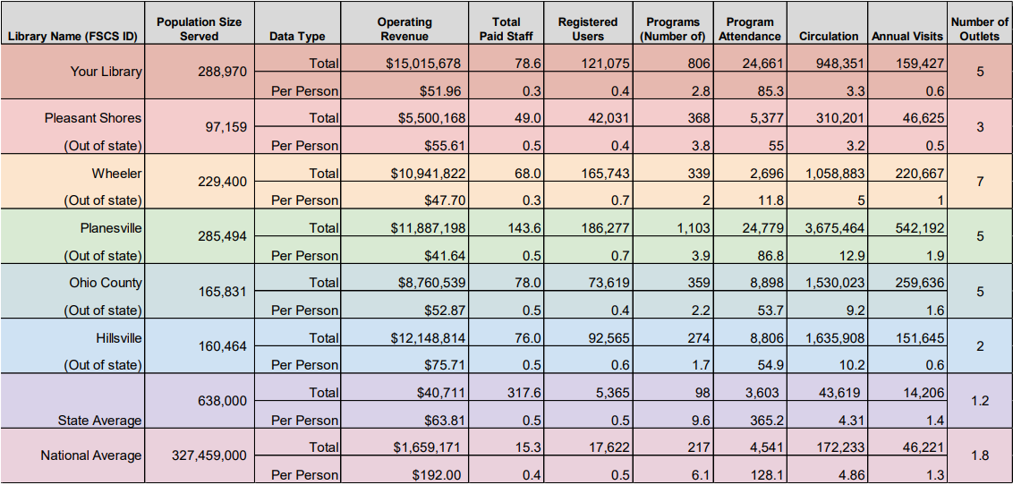

# Bringing it Home - Continue Building Your Peer List

Do this:

1. Return to the table that you built in activities 1 and 2
2. Look up each library in Search and Compare and add them to “My Libraries”
3. Gather data:
   1. You can download your My Libraries list
   2. Or you can use the provided template to enter figures from each library
4. Think critically about the data you have gathered.

* Are there any surprises?
* Does this data suggest anything about your library that you did not know?
* What more do you want to know about the statistics you see?
* What other data will you bring in to contextualize this?

1. Combine Fields to Make Your Own Peer Groups

* Use Search and Compare to dial in libraries that are similar in a variety of criteria.
  + Limit by text-based fields:
    - Fiscal Year
    - State
    - Locale
    - Legal Basis
  + Limit to a range of numeric values
    - Library Buildings
    - Population
    - Visits
    - Programs
    - Staff
    - Revenue
    - Circulation
  + Sort search results to find libraries with similar values in various fields.