Inclusive Data Workshop Live Webinar Handout

Activity 1: Limitations of national Covid data

What national COVID data are being collected/shared and what are the implications?

Go into breakout rooms and spend 10 minutes doing the following. Prepare a few ideas that arose in your discussion to share with the larger group.
- Go to the CDC COVID data dashboard
- As a group, choose a state and think about 3 COVID-related indicators you are interested in knowing about the state. Search for those indicators in the CDC and linked data.
- After playing around with the data for a few minutes, which voices do you find are included in the data and which voices are marginalized/missing? To what extent does the data presented represent the realities of your community?
- Discuss what other data you would need to better understand the impacts of COVID-19 in your community
- And what are the implications of data not being available?

A moment of reflexivity
What aspects of your assumptions, experiences, knowledge, and power/privilege could impact how you are viewing/interpreting/framing the issue? What do you know and what are the limitations of your knowledge?

Activity 2: Defining the social problem affecting your community

What is a social issue affecting your community and what programs and services can libraries design to help mitigate the effects?

In your group, take 5 minutes and discuss the following:
- As a group, select one social issue in a community that libraries could address
- Is this issue affecting everyone in the community or a specific group?
- If the community is diverse, is it appropriate to bring voices from the different groups living in your community?
- Or is it better to compartmentalize the groups (for example, youth, ESL communities, elderly populations, etc.)
**Be prepared to share this with the full group using 1 sentence**

What is the specific issue related to COVID your library would like to address?

Is this issue affecting everyone in your community or a specific group?

If your community is diverse, is it appropriate to bring voices from the different groups living in your community? Or is it better to compartmentalize the groups to have a more productive conversation (for example, youth, ESL communities, elderly populations, etc.)

A moment of reflexivity
What aspects of your assumptions, experiences, knowledge, and power/privilege could impact how you are viewing/interpreting/framing the issue? What do you know and what are the limitations of your knowledge?

Activity 3: Building a Stakeholder Map
Consider the social issue you developed with your team.
Go into breakout rooms and spend 10 minutes doing the following. Prepare a few ideas that arose in your discussion to share with the larger group.

- Spend a few minutes listing all the stakeholders that come to mind. Remember, these can include:
  - Who can control it (e.g. through financial, political, or social influence)?
  - Who is impacted by it?
  - Who is knowledgeable about it?
- Using the stakeholder map below, place actors on the axis of “power” and “interest/stake”. Place a dot on the chart in your template where each stakeholder should go.
- Think about the stakeholder map you created. Whose voices are most and least included in shaping our understanding of the issue and the data process needed to identify solutions to this issue?

When you think about your stakeholders, you should consider:
- Communities: Individuals or groups who are affected by the problem.
- Change agents: Individuals and groups directly working on the issue. These include community groups, NGOs, and others on-the-ground.
- Support groups: Foundations, governments, NGOs, and others with resources to address the issue.
- Policymakers: the people who can control government responses to the issue.

Some additional considerations for building your stakeholder map:
- Are there priority populations that should be targeted based on where they fall in the map?
- Are there populations whose power you want to try to increase?
- Are there populations whose interest you want to increase?

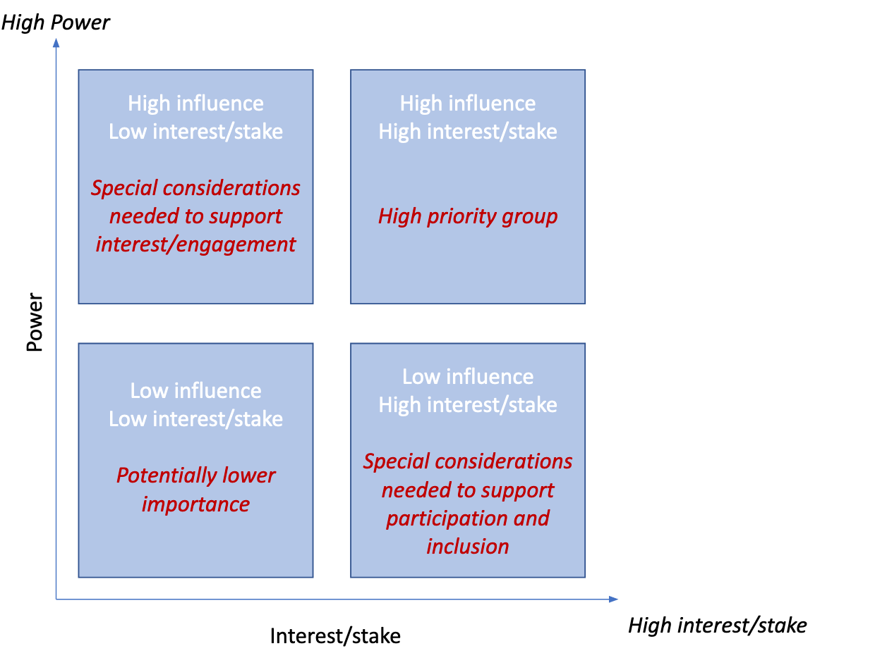
Stakeholder Map Template

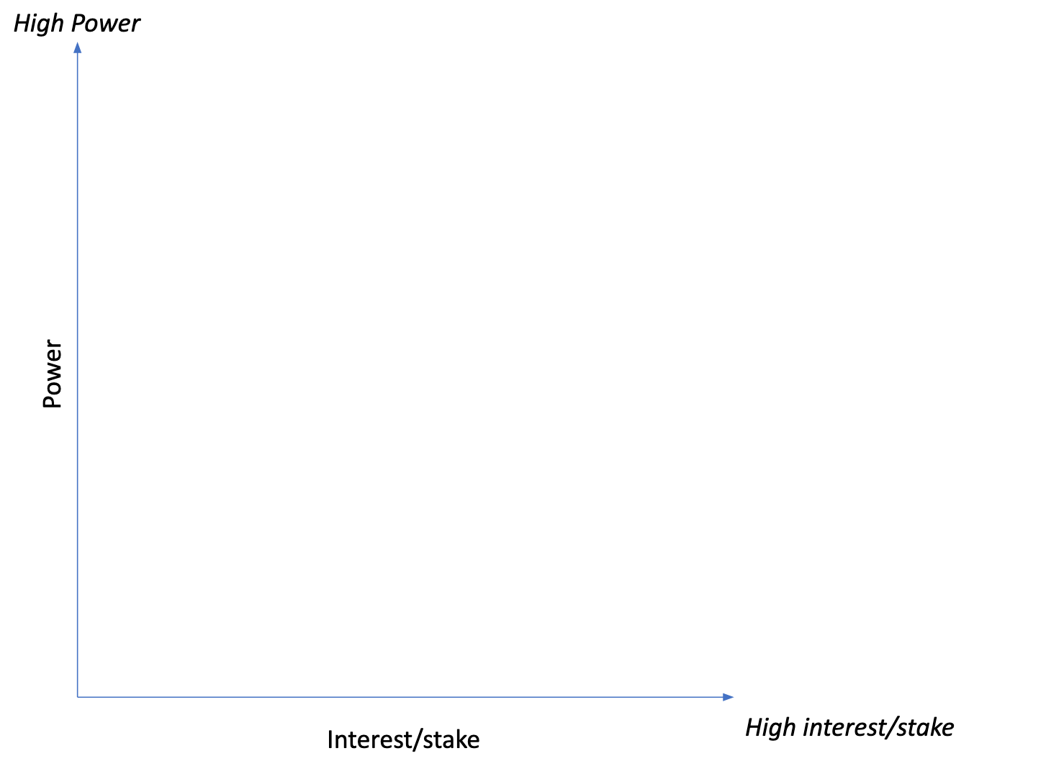

A moment of reflexivity
What aspects of your assumptions, experiences, knowledge, and power/privilege could impact how you are viewing/interpreting/framing the issue? What do you know and what are the limitations of your knowledge?

Activity 4: Assessing Missing Voices in Data
Consider the social issue you developed with your team, and using the Marginalized Voices Framework discussed in the previous slides:
Split into your breakout rooms (10 minutes) and do the following:
- Using your collective knowledge about your communities, identify the critical voices that could potentially be excluded from the data process and are key to addressing the issue
  - Provide the category of voices from the marginalized voices framework that most closely align
  - Provide 2-3 potential reasons why these groups are excluded from the process
  - Briefly describe some potential strategies for inclusion
- Prepare to briefly share with the full group some examples of missing voices and the strategies your team outlined to include them in future data efforts.

Use the marginalized voices matrix below to organize the main points of your discussion
- Unknown voices – people who are invisible from mainstream society and hence invisible to data collection efforts (e.g., uncontacted tribes in the Amazon, modern-day slaves, undocumented migrants). They can be invisible by choice or due to the realities of their lives.
- Silent voices – people who, due to personal and structural factors, lack the capacity of vocalizing their realities (e.g., homeless populations, elderly living in residences, people with disabilities, children).
- Muted voices – people who, because of socially-created systems of classification and power, are devalued and discredited (e.g., LGBTQI community, women, people at the bottom of the social hierarchy, sex workers).
- Unheard voices - people who are excluded from research design and data collection efforts because it is very difficult and costly to reach them using standard data-collection methods and procedures (e.g., people who do not use digital technology, homeless populations, mobile populations without permanent homes, people with low literacy, those who do not speak the language of the country where they live).
- Ignored voices – people who are marginalized during the analysis of the collected data, both through traditional statistical processes and new data approaches. These are individuals who may fall out of calculated averages or have identities whose complexity cannot be captured by the kinds of data collected (e.g., groups who are categorized as “people of color” or other broad ethnic description, groups who are so small in number that their classifications get grouped in “other”).

Marginalized Voices Matrix
Voice that is missing  (list the voice, for example: youth, women, immigrants) | Category of voices based on context of community  (i.e., unknown, silent, muted, unheard, ignored) | Reasons or factors that could affect their participation in data processes | Strategies for inclusion

A moment of reflexivity
What aspects of your assumptions, experiences, knowledge, and power/privilege could impact how you are viewing/interpreting/framing the issue? What do you know and what are the limitations of your knowledge?

Activity 5: Creating data conversations with your community
Consider the social issue you developed with your team.

Go back into your breakout rooms and spend 10 minutes doing the following.
- Describe the kind of community engagement event(s) you would like to plan
- Outline the main objectives
- Describe 2-3 engagement strategies to bring your community voices together, especially those voices that are marginalized in the data and are key in informing solutions to the problem
Think about some considerations to make your community engagement event as inclusive as possible. (e.g. location, time of the day, language, cultural issues)

Type of Community Engagement Event(s)

Main objectives

Engagement strategies

A moment of reflexivity
What aspects of your assumptions, experiences, knowledge, and power/privilege could impact how you are viewing/interpreting/framing the issue? What do you know and what are the limitations of your knowledge?

